AIM:

To install a C compiler in a virtual machine created using VMware Workstation Pro and execute simple C programs to demonstrate program execution in a virtualized environment.

PROCEDURE:

1. Create Virtual Machine
   * Open VMware Workstation Pro and create a new virtual machine.
   * Install an operating system (e.g., Ubuntu/Linux) on the VM.
   * Allocate sufficient resources (CPU, RAM, storage).
2. Install C Compiler
   * Open the terminal in the virtual machine.
   * Update the package list and install the C compiler (GCC).
   * Verify the installation by checking the compiler version.
3. Write a C Program
   * Create a new C file using a text editor in the VM.
   * Enter a simple program such as printing a message or performing a basic calculation.
   * Save the file.
4. Compile and Run Program
   * Compile the program using the C compiler.
   * Run the compiled output file.
   * Observe the program output on the terminal.

Test file: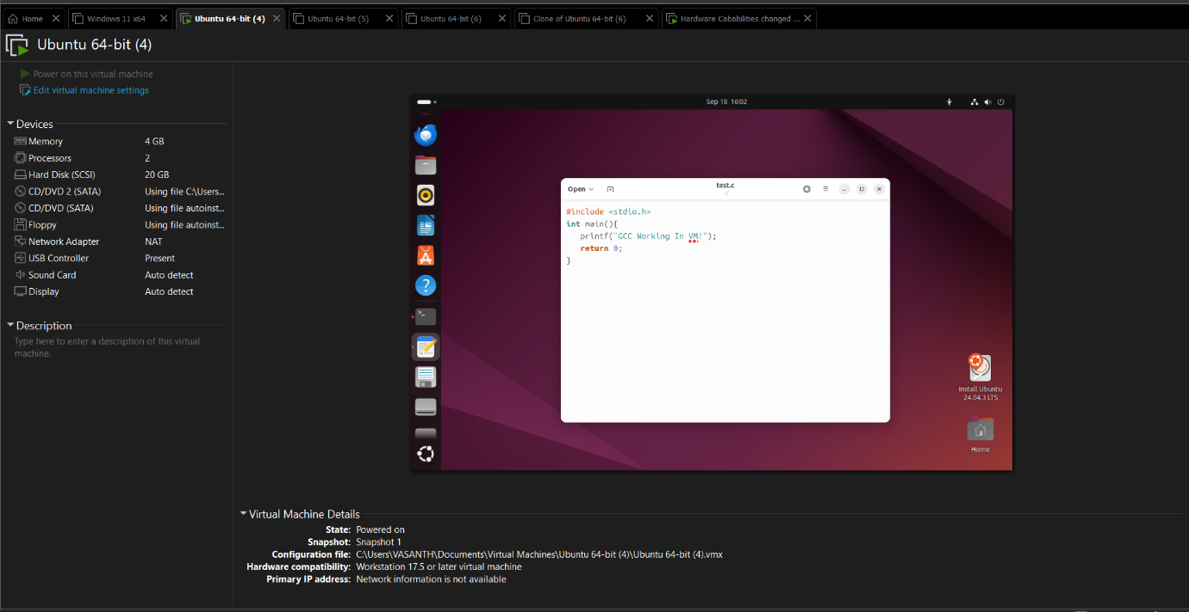

Output:

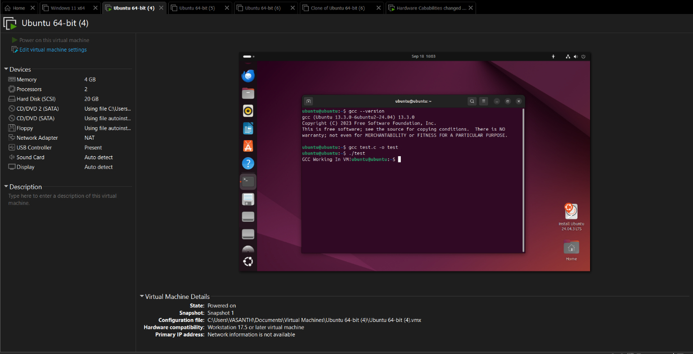

RESULT:

The C compiler was successfully installed inside the virtual machine running on VMware Workstation Pro. A simple C program was compiled and executed, and the correct output was displayed, proving successful configuration and execution in the virtualized environment.